# Exercise: Testing Introduction

Problems for exercises and homework for the ["QA Fundamentals" course @ Software University](https://softuni.bg/courses/qa-fundamentals-internal).

## Find the Errors

You are given a picture of the homepage of Google, opened with a Google Chrome browser. Examine the picture and list the errors you can detect at a first glance. Then, you can open google.com for comparison and list the rest of the errors you have found after seeing it.

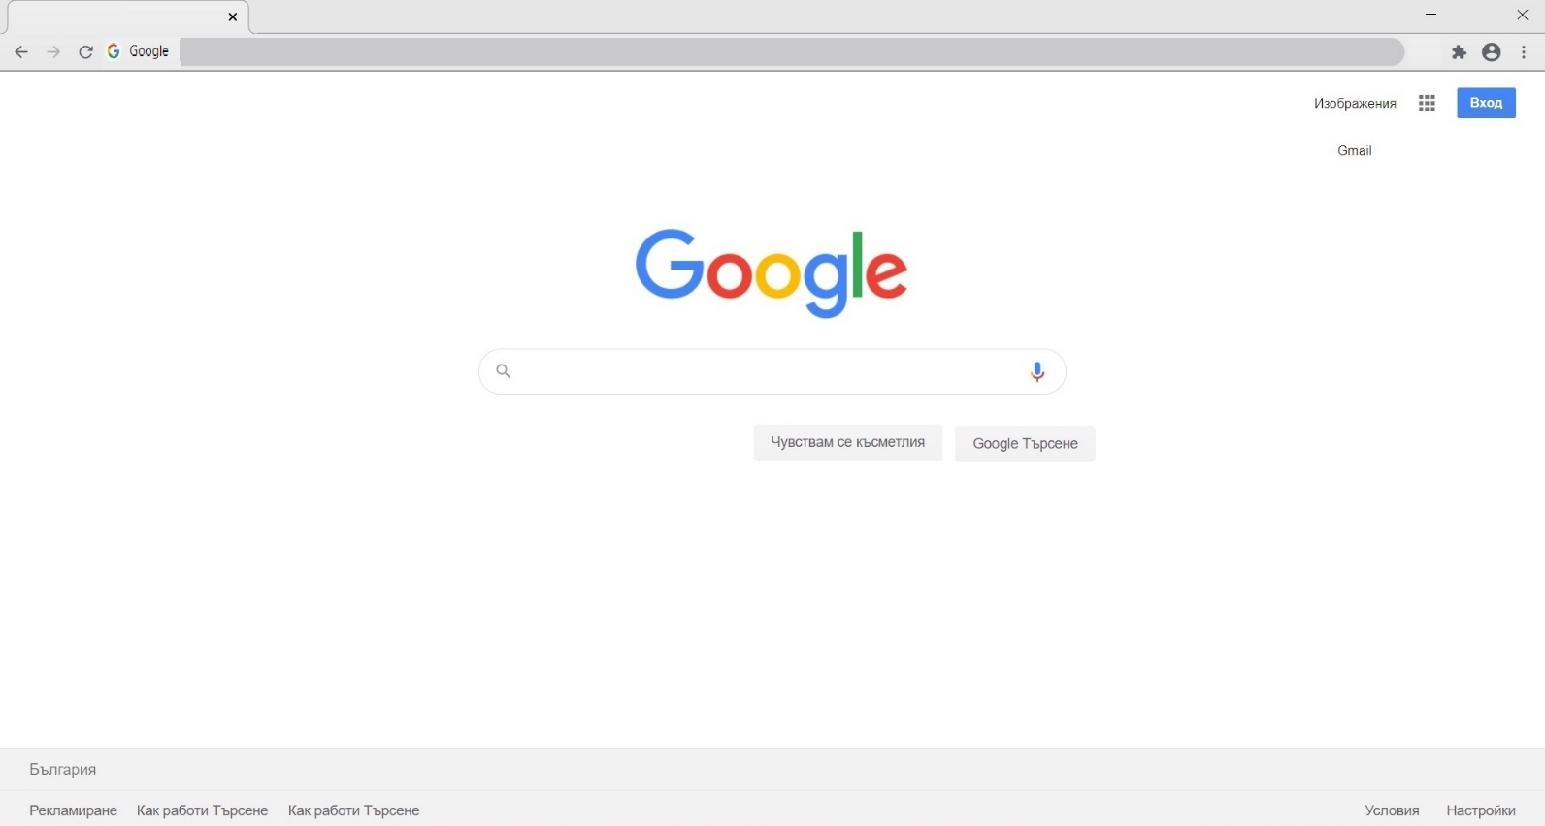

Fill in the table below the number of defects you have found.

|  |  |
| --- | --- |
| Defects: |  |

Look at the legend to judge your results:

|  |  |
| --- | --- |
| Defects Found |  |
| 0 – 2 | **Poor** |
| 2 – 4 | **Average** |
| 5 – 7 | **Good** |
| 8 – 10 defects | **Excellent** |

## Suggest Improvements

The extension of a Software Testing job is to provide suggestions for quality improvements. Take a look at this sign-in form. Think of how user experience can be improved for the following sign-in page:

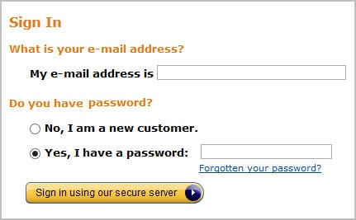

## Think Testing

Here are a couple of cases. Think of all the different and appropriate solutions to them.

* A woman fired a shot at another woman with her gun, but the other woman did not die. Why? List the possible reasons.
* How would you test a 5 kg capacity grocery-shopping paper bag?
* It is time to teach your child to brush its teeth alone. It needs clear step-by-step instruction, so list the steps and be as detailed as you can.

## Test Psychology

It is an exercise from the ISQB textbook "Fundamentals of Software Testing ISTQB Certification".

Read the email below, and see what clues you find to help you identify problems in the scenario described. Categorize the clues/problems as:

• Possible people, psychology, and attitude problems;

• Other problems e.g., possible test management and role problems, possible product problems.

Hi there!

Well, I nearly caused a panic today because I thought I had found a mega showstopper on the trading system we are testing. The test manager and others got involved examining databases first on the server and then on the gateway that feeds the clients, checking update logs from processes that ran overnight as well as checking data passed to the client. Eventually, I found the problem. I had misclicked on a **.bat** file when running up a client and had run up the wrong client environment. By that time, the test manager was ready to say a few short words in my ear, particularly as the development people had started to get involved and they had zero tolerance for mistakes made by testers. The only saving grace was that I found the mistake and not one of the developers.

It was, objectively, an interesting mistake. When you log into the server test environments, the panels always show the environment to which you are connected. In our case, we have two test environments called Systest14 and Systest15, and my tests were set up in Systest15. To run up the clients, we have to run .bat files for either a 14 or 15 client. I had started two clients, that is two exchange participants so that I could do some trading between them.

It appears I started the first client OK in environment 15, but when I started the second, I accidentally moved the mouse a fraction, so it ran the 14 .bat file that is next to it in the Explorer file list. To make matters worse, the client screens do not show the environment to which you are attached.

At first, I felt a bit stupid, having caused much hectic and wasted activity. On reflection, I thought that if I, as a reasonably competent person, can make a mistake like this, something is wrong. On the server-side, when I log on to a test environment, I have to enter the environment name, and it's shown on all the panels. On the client-side, I run a client test environment by selecting a .bat file from a list of many and have to ensure I click on the right file. There is neither a display nor the ability to determine the client environment in which I am working.

So I will log this as a high priority, or even showstopper, error - the client does not show the environment. In real-life terms, it means a real user could be connected to the production system and think he is connected to a test system and screw up trading. I know this happened once on the equities trading system when a trader entered a load of test transactions into the production system by mistake and caused mayhem.

As an addendum to this story, a couple of days later, one of the testers found what appeared to be another mega showstopper. He and the test manager spent three hours crawling all over the system before discovering the 'error'. A new filter had been added to the client software to filter transactions displayed in panels by geographical market. Unknown to them, it was set to a default of the German market, whereas they thought they were in the UK market. Consequently, at first sight, it appeared there were fundamental problems with the network transaction bus and the message-broadcasting systems. Apart from the issue that they should have been informed of this change, it raised a similar problem to the one I had experienced -the client system does not display the market in which you are trading.

Well - I'm off for another happy day at the office! All the best!